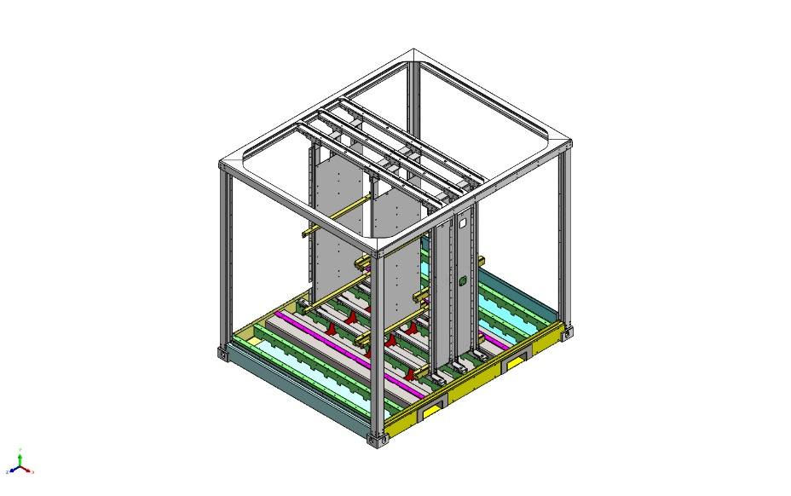
  Simulation of P000014110FLR
  Date: Thursday, June 11, 2026
  Designer: Solidworks
  Study name: Static 1
  Analysis type: Static
  Table of Contents
  Description 1
  Assumptions 2
  Model Information 3
  Study Properties 9
  Units 9
  Material Properties 10
  Loads and Fixtures 22
  Connector Definitions 23
  Contact Information 24
  Mesh information 26
  Sensor Details 28
  Resultant Forces 28
  Beams 28
  Study Results 29
  Conclusion 32
  Appendix 32

Description
No Data

Assumptions

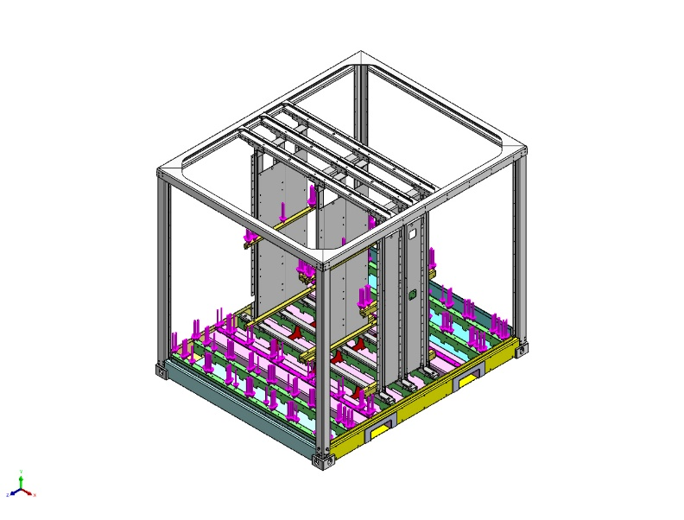  Original Model | 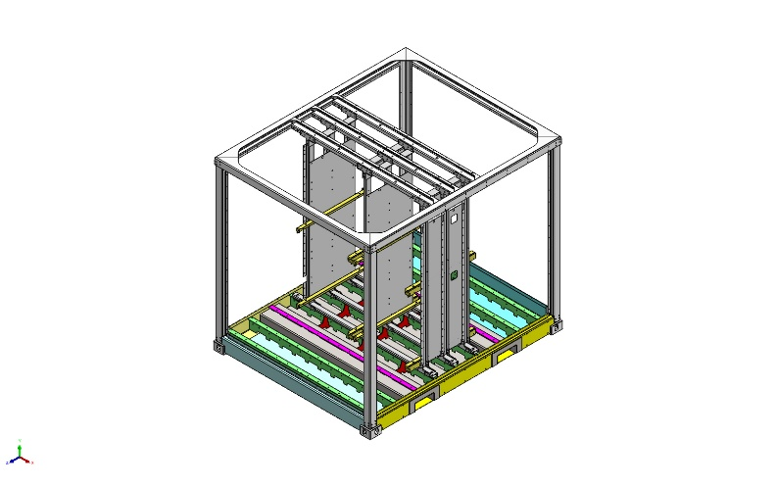  Model Analyzed

Model Information

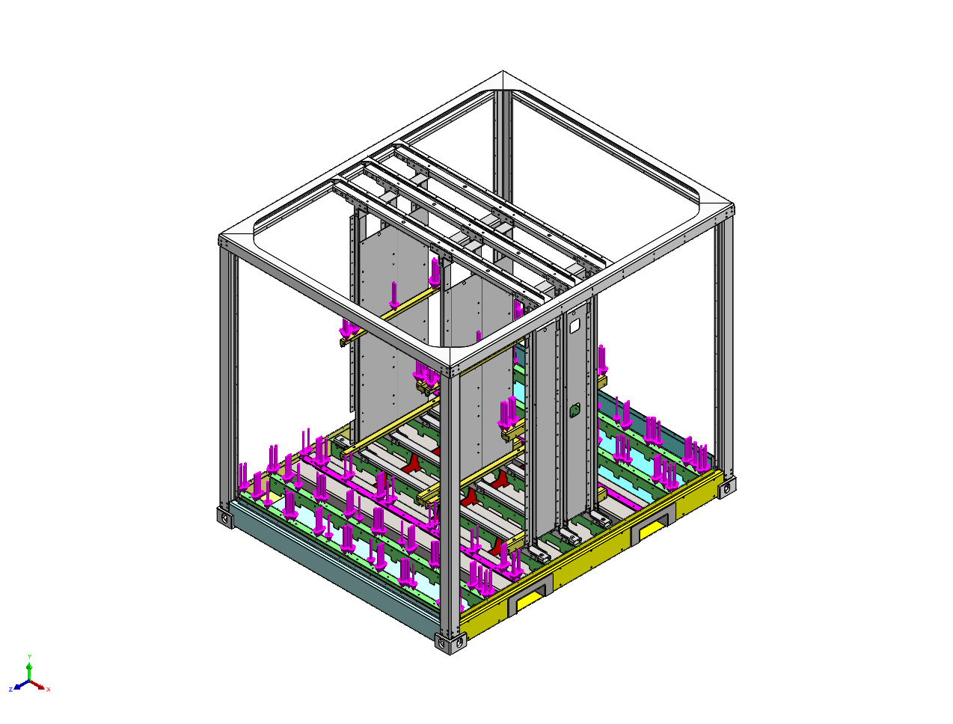
Model name: P000014110FLR
Current Configuration: Default
Solid Bodies
Document Name and Reference | Treated As | Volumetric Properties | Document Path/Date Modified
Cut-Extrude1 | Solid Body | Mass:18.295 kg  Volume:0.00234552 m^3  Density:7,800 kg/m^3  Weight:179.291 N | G:\03_Projects_Business_Dev\00056 e-PU10 V1\04_Engineering\05) Mechanical stress analysis\e-PU battery rack brake V6 (e-stop) 2025\FEM2P000009263.SLDPRT  May 6 10:33:00 2024
Cut-Extrude1 | Solid Body | Mass:18.295 kg  Volume:0.00234552 m^3  Density:7,800 kg/m^3  Weight:179.291 N | G:\03_Projects_Business_Dev\00056 e-PU10 V1\04_Engineering\05) Mechanical stress analysis\e-PU battery rack brake V6 (e-stop) 2025\FEM2P000009263.SLDPRT  May 6 10:33:00 2024
Cut-Extrude1 | Solid Body | Mass:18.295 kg  Volume:0.00234552 m^3  Density:7,800 kg/m^3  Weight:179.291 N | G:\03_Projects_Business_Dev\00056 e-PU10 V1\04_Engineering\05) Mechanical stress analysis\e-PU battery rack brake V6 (e-stop) 2025\FEM2P000009263.SLDPRT  May 6 10:33:00 2024
Ø13.0 (13) Diameter Slot2 | Solid Body | Mass:0.812536 kg  Volume:0.000104171 m^3  Density:7,800 kg/m^3  Weight:7.96285 N | G:\03_Projects_Business_Dev\00056 e-PU10 V1\04_Engineering\05) Mechanical stress analysis\e-PU battery rack brake V6 (e-stop) 2025\FEM2P000010107.SLDPRT  Nov 14 17:04:42 2023
Ø13.0 (13) Diameter Slot2 | Solid Body | Mass:0.812536 kg  Volume:0.000104171 m^3  Density:7,800 kg/m^3  Weight:7.96285 N | G:\03_Projects_Business_Dev\00056 e-PU10 V1\04_Engineering\05) Mechanical stress analysis\e-PU battery rack brake V6 (e-stop) 2025\FEM2P000010107.SLDPRT  Nov 14 17:04:42 2023
Ø13.0 (13) Diameter Slot2 | Solid Body | Mass:0.812536 kg  Volume:0.000104171 m^3  Density:7,800 kg/m^3  Weight:7.96285 N | G:\03_Projects_Business_Dev\00056 e-PU10 V1\04_Engineering\05) Mechanical stress analysis\e-PU battery rack brake V6 (e-stop) 2025\FEM2P000010107.SLDPRT  Nov 14 17:04:42 2023
CSK for M1.6 Countersunk Flat Head Screw2 | Solid Body | Mass:17.2863 kg  Volume:0.00221619 m^3  Density:7,800 kg/m^3  Weight:169.406 N | G:\03_Projects_Business_Dev\00056 e-PU10 V1\04_Engineering\05) Mechanical stress analysis\e-PU battery rack brake V6 (e-stop) 2025\FEM2P000010224.SLDPRT  May 6 10:31:28 2024
CSK for M1.6 Countersunk Flat Head Screw2 | Solid Body | Mass:17.2863 kg  Volume:0.00221619 m^3  Density:7,800 kg/m^3  Weight:169.406 N | G:\03_Projects_Business_Dev\00056 e-PU10 V1\04_Engineering\05) Mechanical stress analysis\e-PU battery rack brake V6 (e-stop) 2025\FEM2P000010224.SLDPRT  May 6 10:31:28 2024
CSK for M1.6 Countersunk Flat Head Screw2 | Solid Body | Mass:17.2863 kg  Volume:0.00221619 m^3  Density:7,800 kg/m^3  Weight:169.406 N | G:\03_Projects_Business_Dev\00056 e-PU10 V1\04_Engineering\05) Mechanical stress analysis\e-PU battery rack brake V6 (e-stop) 2025\FEM2P000010224.SLDPRT  May 6 10:31:28 2024
Ø13.0 (13) Diameter Slot2 | Solid Body | Mass:1.19805 kg  Volume:0.000153596 m^3  Density:7,800 kg/m^3  Weight:11.7408 N | G:\03_Projects_Business_Dev\00056 e-PU10 V1\04_Engineering\05) Mechanical stress analysis\e-PU battery rack brake V6 (e-stop) 2025\FEM2P000010308.SLDPRT  Nov 14 17:04:42 2023
Ø13.0 (13) Diameter Slot2 | Solid Body | Mass:1.19805 kg  Volume:0.000153596 m^3  Density:7,800 kg/m^3  Weight:11.7408 N | G:\03_Projects_Business_Dev\00056 e-PU10 V1\04_Engineering\05) Mechanical stress analysis\e-PU battery rack brake V6 (e-stop) 2025\FEM2P000010308.SLDPRT  Nov 14 17:04:42 2023
Ø13.0 (13) Diameter Slot2 | Solid Body | Mass:1.19805 kg  Volume:0.000153596 m^3  Density:7,800 kg/m^3  Weight:11.7408 N | G:\03_Projects_Business_Dev\00056 e-PU10 V1\04_Engineering\05) Mechanical stress analysis\e-PU battery rack brake V6 (e-stop) 2025\FEM2P000010308.SLDPRT  Nov 14 17:04:42 2023
CSK for M1.6 Countersunk Flat Head Screw6 | Solid Body | Mass:24.6142 kg  Volume:0.00315567 m^3  Density:7,800 kg/m^3  Weight:241.219 N | G:\03_Projects_Business_Dev\00056 e-PU10 V1\04_Engineering\05) Mechanical stress analysis\e-PU battery rack brake V6 (e-stop) 2025\FEM2P000010328.SLDPRT  May 6 10:29:12 2024
CSK for M1.6 Countersunk Flat Head Screw6 | Solid Body | Mass:24.6142 kg  Volume:0.00315567 m^3  Density:7,800 kg/m^3  Weight:241.219 N | G:\03_Projects_Business_Dev\00056 e-PU10 V1\04_Engineering\05) Mechanical stress analysis\e-PU battery rack brake V6 (e-stop) 2025\FEM2P000010328.SLDPRT  May 6 10:29:12 2024
CSK for M1.6 Countersunk Flat Head Screw6 | Solid Body | Mass:24.6142 kg  Volume:0.00315567 m^3  Density:7,800 kg/m^3  Weight:241.219 N | G:\03_Projects_Business_Dev\00056 e-PU10 V1\04_Engineering\05) Mechanical stress analysis\e-PU battery rack brake V6 (e-stop) 2025\FEM2P000010328.SLDPRT  May 6 10:29:12 2024
Fillet11  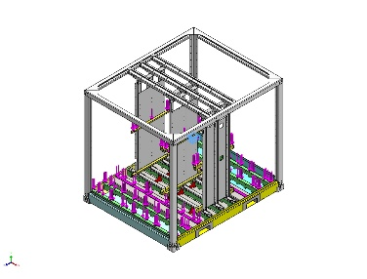 | Solid Body | Mass:12.3782 kg  Volume:0.00157523 m^3  Density:7,858 kg/m^3  Weight:121.306 N | G:\03_Projects_Business_Dev\00056 e-PU10 V1\04_Engineering\05) Mechanical stress analysis\Floor okt 2025\P000008405FLR.SLDPRT  Sep 9 07:22:34 2025
Fillet11  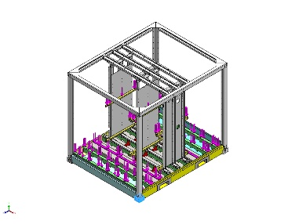 | Solid Body | Mass:12.3782 kg  Volume:0.00157523 m^3  Density:7,858 kg/m^3  Weight:121.306 N | G:\03_Projects_Business_Dev\00056 e-PU10 V1\04_Engineering\05) Mechanical stress analysis\Floor okt 2025\P000008405FLR.SLDPRT  Sep 9 07:22:34 2025
<P000003232>-<Fillet11> | Solid Body | Mass:12.3783 kg  Volume:0.00157524 m^3  Density:7,858.04 kg/m^3  Weight:121.307 N | G:\03_Projects_Business_Dev\00056 e-PU10 V1\04_Engineering\05) Mechanical stress analysis\Floor okt 2025\P000008411FLR.sldprt  Oct 13 12:59:26 2025
<P000003232>-<Fillet11> | Solid Body | Mass:12.3783 kg  Volume:0.00157524 m^3  Density:7,858.04 kg/m^3  Weight:121.307 N | G:\03_Projects_Business_Dev\00056 e-PU10 V1\04_Engineering\05) Mechanical stress analysis\Floor okt 2025\P000008411FLR.sldprt  Oct 13 12:59:26 2025
Boss-Extrude1  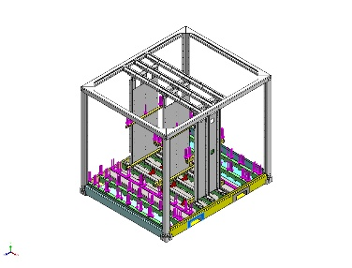 | Solid Body | Mass:3.60204 kg  Volume:0.0004618 m^3  Density:7,800 kg/m^3  Weight:35.3 N | C:\Users\pdmdesktop\AppData\Local\Temp\swx123644\VC~~\P000014110FLR\Part1^P000014110FLR.SLDPRT  Jun 11 12:31:23 2026
Boss-Extrude1  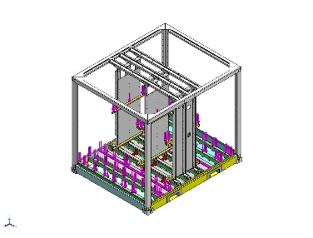 | Solid Body | Mass:3.60204 kg  Volume:0.0004618 m^3  Density:7,800 kg/m^3  Weight:35.3 N | C:\Users\pdmdesktop\AppData\Local\Temp\swx123644\VC~~\P000014110FLR\Part1^P000014110FLR.SLDPRT  Jun 11 12:31:23 2026
Boss-Extrude1  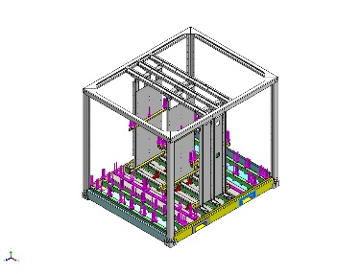 | Solid Body | Mass:3.60204 kg  Volume:0.0004618 m^3  Density:7,800 kg/m^3  Weight:35.3 N | C:\Users\pdmdesktop\AppData\Local\Temp\swx123644\VC~~\P000014110FLR\Part1^P000014110FLR.SLDPRT  Jun 11 12:31:23 2026
Boss-Extrude1  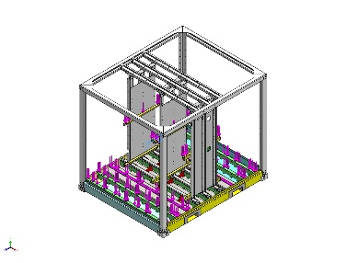 | Solid Body | Mass:3.60204 kg  Volume:0.0004618 m^3  Density:7,800 kg/m^3  Weight:35.3 N | C:\Users\pdmdesktop\AppData\Local\Temp\swx123644\VC~~\P000014110FLR\Part1^P000014110FLR.SLDPRT  Jun 11 12:31:23 2026

Study Properties
Study name | Static 1
Analysis type | Static
Mesh type | Mixed Mesh
Thermal Effect: | On
Thermal option | Include temperature loads
Zero strain temperature | 298 Kelvin
Include fluid pressure effects from SOLIDWORKS Flow Simulation | Off
Solver type | FFEPlus
Inplane Effect: | Off
Soft Spring: | Off
Inertial Relief: | Off
Incompatible bonding options | Automatic
Large displacement | Off
Compute free body forces | On
Friction | Off
Use Adaptive Method: | Off
Result folder | SOLIDWORKS document (G:\03_Projects_Business_Dev\00056 e-PU10 V1\04_Engineering\05) Mechanical stress analysis\Floor okt 2025)

Units
Unit system: | SI (MKS)
Length/Displacement | mm
Temperature | Kelvin
Angular velocity | Rad/sec
Pressure/Stress | N/m^2

Material Properties
Model Reference | Properties | Components
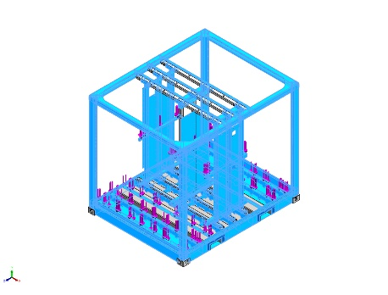 |  | SolidBody 1(Ø9.1 (9.1) Diameter Hole2)(FEM2P000013056-1/FEM2P000011093-1/FEM2P000009265-2/FEM2P000009247-10),  SolidBody 1(Ø9.1 (9.1) Diameter Hole2)(FEM2P000013056-1/FEM2P000011093-1/FEM2P000009265-2/FEM2P000009247-16),  SolidBody 1(Ø9.1 (9.1) Diameter Hole2)(FEM2P000013056-1/FEM2P000011093-1/FEM2P000009265-2/FEM2P000009247-17),  SolidBody 1(Ø9.1 (9.1) Diameter Hole2)(FEM2P000013056-1/FEM2P000011093-1/FEM2P000009265-2/FEM2P000009247-19),  SolidBody 1(Ø9.1 (9.1) Diameter Hole2)(FEM2P000013056-1/FEM2P000011093-1/FEM2P000009265-2/FEM2P000009247-20),  SolidBody 1(Ø9.1 (9.1) Diameter Hole2)(FEM2P000013056-1/FEM2P000011093-1/FEM2P000009265-2/FEM2P000009247-9),  SolidBody 1(Ø13.0 (13) Diameter Hole1)(FEM2P000013056-1/FEM2P000011093-1/FEM2P000009265-2/FEM2P000009740-1),  SolidBody 1(Ø13.0 (13) Diameter Hole1)(FEM2P000013056-1/FEM2P000011093-1/FEM2P000009265-2/FEM2P000009740-10),  SolidBody 1(Ø13.0 (13) Diameter Hole1)(FEM2P000013056-1/FEM2P000011093-1/FEM2P000009265-2/FEM2P000009740-11),  SolidBody 1(Ø13.0 (13) Diameter Hole1)(FEM2P000013056-1/FEM2P000011093-1/FEM2P000009265-2/FEM2P000009740-12),  SolidBody 1(Ø13.0 (13) Diameter Hole1)(FEM2P000013056-1/FEM2P000011093-1/FEM2P000009265-2/FEM2P000009740-25),  SolidBody 1(Ø13.0 (13) Diameter Hole1)(FEM2P000013056-1/FEM2P000011093-1/FEM2P000009265-2/FEM2P000009740-26),  SolidBody 1(Ø13.0 (13) Diameter Hole1)(FEM2P000013056-1/FEM2P000011093-1/FEM2P000009265-2/FEM2P000009740-27),  SolidBody 1(Ø13.0 (13) Diameter Hole1)(FEM2P000013056-1/FEM2P000011093-1/FEM2P000009265-2/FEM2P000009740-28),  SolidBody 1(Ø13.0 (13) Diameter Hole1)(FEM2P000013056-1/FEM2P000011093-1/FEM2P000009265-2/FEM2P000009740-29),  SolidBody 1(Ø13.0 (13) Diameter Hole1)(FEM2P000013056-1/FEM2P000011093-1/FEM2P000009265-2/FEM2P000009740-30),  SolidBody 1(Ø13.0 (13) Diameter Hole1)(FEM2P000013056-1/FEM2P000011093-1/FEM2P000009265-2/FEM2P000009740-31),  SolidBody 1(Ø13.0 (13) Diameter Hole1)(FEM2P000013056-1/FEM2P000011093-1/FEM2P000009265-2/FEM2P000009740-32),  SolidBody 1(Ø13.0 (13) Diameter Hole1)(FEM2P000013056-1/FEM2P000011093-1/FEM2P000009265-2/FEM2P000009740-33),  SolidBody 1(Ø13.0 (13) Diameter Hole1)(FEM2P000013056-1/FEM2P000011093-1/FEM2P000009265-2/FEM2P000009740-34),  SolidBody 1(Ø13.0 (13) Diameter Hole1)(FEM2P000013056-1/FEM2P000011093-1/FEM2P000009265-2/FEM2P000009740-35),  SolidBody 1(Ø13.0 (13) Diameter Hole1)(FEM2P000013056-1/FEM2P000011093-1/FEM2P000009265-2/FEM2P000009740-36),  SolidBody 1(Ø13.0 (13) Diameter Hole1)(FEM2P000013056-1/FEM2P000011093-1/FEM2P000009265-2/FEM2P000009740-8),  SolidBody 1(Ø13.0 (13) Diameter Hole1)(FEM2P000013056-1/FEM2P000011093-1/FEM2P000009265-2/FEM2P000009740-9),  SolidBody 1(Fillet2)(FEM2P000013056-1/FEM2P000011093-1/FEM2P000009265-2/FEM2P000009771-6),  SolidBody 1(Fillet1)(FEM2P000013056-1/FEM2P000011093-1/FEM2P000009265-2/FEM2P000010101-1),  SolidBody 1(Fillet1)(FEM2P000013056-1/FEM2P000011093-1/FEM2P000009265-2/FEM2P000010101-2),  SolidBody 1(Fillet1)(FEM2P000013056-1/FEM2P000011093-1/FEM2P000009265-2/FEM2P000010101-3),  SolidBody 1(Fillet1)(FEM2P000013056-1/FEM2P000011093-1/FEM2P000009265-2/FEM2P000010101-4),  SolidBody 1(Ø13.0 (13) Diameter Slot2)(FEM2P000013056-1/FEM2P000011093-1/FEM2P000009265-2/FEM2P000010107-1),  SolidBody 1(Ø13.0 (13) Diameter Slot2)(FEM2P000013056-1/FEM2P000011093-1/FEM2P000009265-2/FEM2P000010107-2),  SolidBody 1(Ø13.0 (13) Diameter Slot2)(FEM2P000013056-1/FEM2P000011093-1/FEM2P000009265-2/FEM2P000010107-3),  SolidBody 1(Fillet1)(FEM2P000013056-1/FEM2P000011093-1/FEM2P000009265-2/FEM2P000010211-1),  SolidBody 1(Fillet1)(FEM2P000013056-1/FEM2P000011093-1/FEM2P000009265-2/FEM2P000010211-2),  SolidBody 1(Fillet1)(FEM2P000013056-1/FEM2P000011093-1/FEM2P000009265-2/FEM2P000010211-3),  SolidBody 1(Fillet1)(FEM2P000013056-1/FEM2P000011093-1/FEM2P000009265-2/FEM2P000010211-4),  SolidBody 1(Fillet1)(FEM2P000013056-1/FEM2P000011093-1/FEM2P000009265-2/FEM2P000010211-5),  SolidBody 1(Fillet1)(FEM2P000013056-1/FEM2P000011093-1/FEM2P000009265-2/FEM2P000010211-6),  SolidBody 1(Fillet1)(FEM2P000013056-1/FEM2P000011093-1/FEM2P000009265-2/FEM2P000010211-7),  SolidBody 1(Fillet1)(FEM2P000013056-1/FEM2P000011093-1/FEM2P000009265-2/FEM2P000010211-8),  SolidBody 1(Fillet1)(FEM2P000013056-1/FEM2P000011093-1/FEM2P000009265-2/FEM2P000010211-9),  SolidBody 1(Fillet1)(FEM2P000013056-1/FEM2P000011093-1/FEM2P000009265-2/FEM2P000010232-7),  SolidBody 1(Fillet1)(FEM2P000013056-1/FEM2P000011093-1/FEM2P000009265-2/FEM2P000010232-8),  SolidBody 1(Ø10.0 (10) Diameter Slot1)(FEM2P000013056-1/FEM2P000011093-1/FEM2P000009265-2/FEM2P000010259-103),  SolidBody 1(Ø10.0 (10) Diameter Slot1)(FEM2P000013056-1/FEM2P000011093-1/FEM2P000009265-2/FEM2P000010259-110),  SolidBody 1(Ø10.0 (10) Diameter Slot1)(FEM2P000013056-1/FEM2P000011093-1/FEM2P000009265-2/FEM2P000010259-32),  SolidBody 1(Ø10.0 (10) Diameter Slot1)(FEM2P000013056-1/FEM2P000011093-1/FEM2P000009265-2/FEM2P000010259-79),  SolidBody 1(Ø10.0 (10) Diameter Slot1)(FEM2P000013056-1/FEM2P000011093-1/FEM2P000009265-2/FEM2P000010259-80),  SolidBody 1(Ø10.0 (10) Diameter Slot1)(FEM2P000013056-1/FEM2P000011093-1/FEM2P000009265-2/FEM2P000010259-81),  SolidBody 1(Ø10.0 (10) Diameter Slot1)(FEM2P000013056-1/FEM2P000011093-1/FEM2P000009265-2/FEM2P000010259-89),  SolidBody 1(Ø10.0 (10) Diameter Slot1)(FEM2P000013056-1/FEM2P000011093-1/FEM2P000009265-2/FEM2P000010259-96),  SolidBody 1(Ø13.0 (13) Diameter Hole1)(FEM2P000013056-1/FEM2P000011093-1/FEM2P000009265-2/FEM2P000010268-44),  SolidBody 1(Ø13.0 (13) Diameter Hole1)(FEM2P000013056-1/FEM2P000011093-1/FEM2P000009265-2/FEM2P000010268-45),  SolidBody 1(Ø13.0 (13) Diameter Hole1)(FEM2P000013056-1/FEM2P000011093-1/FEM2P000009265-2/FEM2P000010268-46),  SolidBody 1(Ø13.0 (13) Diameter Hole1)(FEM2P000013056-1/FEM2P000011093-1/FEM2P000009265-2/FEM2P000010268-47),  SolidBody 1(Ø13.0 (13) Diameter Hole1)(FEM2P000013056-1/FEM2P000011093-1/FEM2P000009265-2/FEM2P000010268-48),  SolidBody 1(Ø13.0 (13) Diameter Hole1)(FEM2P000013056-1/FEM2P000011093-1/FEM2P000009265-2/FEM2P000010268-49),  SolidBody 1(Ø13.0 (13) Diameter Hole1)(FEM2P000013056-1/FEM2P000011093-1/FEM2P000009265-2/FEM2P000010268-50),  SolidBody 1(Ø13.0 (13) Diameter Hole1)(FEM2P000013056-1/FEM2P000011093-1/FEM2P000009265-2/FEM2P000010268-51),  SolidBody 1(Ø13.0 (13) Diameter Hole1)(FEM2P000013056-1/FEM2P000011093-1/FEM2P000009265-2/FEM2P000010268-52),  SolidBody 1(Ø13.0 (13) Diameter Hole1)(FEM2P000013056-1/FEM2P000011093-1/FEM2P000009265-2/FEM2P000010268-53),  SolidBody 1(Ø13.0 (13) Diameter Hole1)(FEM2P000013056-1/FEM2P000011093-1/FEM2P000009265-2/FEM2P000010268-54),  SolidBody 1(Ø13.0 (13) Diameter Hole1)(FEM2P000013056-1/FEM2P000011093-1/FEM2P000009265-2/FEM2P000010268-55),  SolidBody 1(Ø13.0 (13) Diameter Hole1)(FEM2P000013056-1/FEM2P000011093-1/FEM2P000009265-2/FEM2P000010268-56),  SolidBody 1(Ø13.0 (13) Diameter Hole1)(FEM2P000013056-1/FEM2P000011093-1/FEM2P000009265-2/FEM2P000010268-57),  SolidBody 1(Ø13.0 (13) Diameter Hole1)(FEM2P000013056-1/FEM2P000011093-1/FEM2P000009265-2/FEM2P000010268-58),  SolidBody 1(Ø13.0 (13) Diameter Hole1)(FEM2P000013056-1/FEM2P000011093-1/FEM2P000009265-2/FEM2P000010268-59),  SolidBody 1(Ø13.0 (13) Diameter Hole1)(FEM2P000013056-1/FEM2P000011093-1/FEM2P000009265-2/FEM2P000010268-60),  SolidBody 1(Ø13.0 (13) Diameter Hole1)(FEM2P000013056-1/FEM2P000011093-1/FEM2P000009265-2/FEM2P000010268-61),  SolidBody 1(Ø13.0 (13) Diameter Slot2)(FEM2P000013056-1/FEM2P000011093-1/FEM2P000009265-2/FEM2P000010308-4),  SolidBody 1(Ø13.0 (13) Diameter Slot2)(FEM2P000013056-1/FEM2P000011093-1/FEM2P000009265-2/FEM2P000010308-5),  SolidBody 1(Ø13.0 (13) Diameter Slot2)(FEM2P000013056-1/FEM2P000011093-1/FEM2P000009265-2/FEM2P000010308-6),  SolidBody 1(Mirror2)(P000008408-1),  SolidBody 1(Mirror2)(P000008408-2),  SolidBody 1(Mirror2)(P000008408-3),  SolidBody 1(Mirror2)(P000008408-4),  SolidBody 1(Break-Corner1)(P000008438-1),  SolidBody 1(Break-Corner1)(P000008438-2),  SolidBody 1(Mirror2)(P000008449-1),  SolidBody 1(Mirror2)(P000008449-2),  SolidBody 1(Mirror2)(P000008449-3),  SolidBody 1(Mirror2)(P000008449-4),  SolidBody 1(LPattern5)(P000008452-1),  SolidBody 1(<P000008452>-<LPattern5>)(P000008452M-1),  SolidBody 1(<P000014130FLR>-<Fillet2>)(P000014129FLR-4),  SolidBody 1(Fillet2)(P000014130FLR-1),  SolidBody 1(Fillet1)(P000014131FLR-1),  SolidBody 1(Fillet1)(P000014131FLR-2),  SolidBody 1(Fillet1)(P000014131FLR-3),  SolidBody 1(Fillet1)(P000014131FLR-4),  SolidBody 1(Fillet1)(P000014131FLR-5),  SolidBody 1(Fillet1)(P000014131FLR-6),  SolidBody 1(Fillet1)(P000014131FLR-7),  SolidBody 1(<P000014138FLR>-<M6 Tapped Hole1>)(P000014137FLR-1),  SolidBody 1(M6 Tapped Hole1)(P000014138FLR-2),  SolidBody 1(Cut-Extrude8)(P000014145FLR-1),  SolidBody 1(Cut-Extrude8)(P000014145FLR-3),  SolidBody 1(Ø12.0 (12) Diameter Hole1)(P000014148FLR-1),  SolidBody 1(Ø12.0 (12) Diameter Hole1)(P000014148FLR-10),  SolidBody 1(Ø12.0 (12) Diameter Hole1)(P000014148FLR-11),  SolidBody 1(Ø12.0 (12) Diameter Hole1)(P000014148FLR-3),  SolidBody 1(Ø12.0 (12) Diameter Hole1)(P000014148FLR-4),  SolidBody 1(Ø12.0 (12) Diameter Hole1)(P000014148FLR-5),  SolidBody 1(Ø12.0 (12) Diameter Hole1)(P000014148FLR-6),  SolidBody 1(Ø12.0 (12) Diameter Hole1)(P000014148FLR-9),  SolidBody 1(Fillet1)(P000014149FLR-1),  SolidBody 1(Fillet1)(P000014149FLR-2),  SolidBody 1(Fillet1)(P000014149FLR-3),  SolidBody 1(Boss-Extrude1)(Part1^P000014110FLR-1),  SolidBody 1(Boss-Extrude1)(Part1^P000014110FLR-2),  SolidBody 1(Boss-Extrude1)(Part1^P000014110FLR-3),  SolidBody 1(Boss-Extrude1)(Part1^P000014110FLR-4)
  Name: | 1.0976 (S355MC)
  Model type: | Linear Elastic Isotropic
  Default failure criterion: | Unknown
  Yield strength: | 3.15e+08 N/m^2
  Tensile strength: | 4.9e+08 N/m^2
  Elastic modulus: | 2.1e+11 N/m^2
  Poisson's ratio: | 0.28
  Mass density: | 7,800 kg/m^3
  Shear modulus: | 7.9e+10 N/m^2
  Thermal expansion coefficient: | 1.1e-05 /Kelvin
Curve Data:N/A
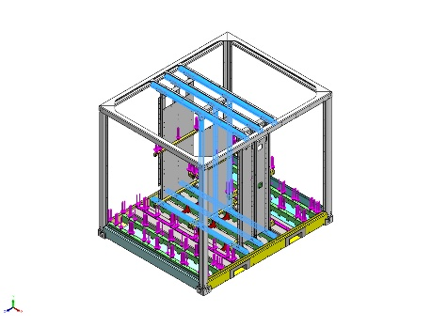 |  | SolidBody 1(Cut-Extrude1)(FEM2P000013056-1/FEM2P000011093-1/FEM2P000009265-2/FEM2P000009263-1),  SolidBody 1(Cut-Extrude1)(FEM2P000013056-1/FEM2P000011093-1/FEM2P000009265-2/FEM2P000009263-5),  SolidBody 1(Cut-Extrude1)(FEM2P000013056-1/FEM2P000011093-1/FEM2P000009265-2/FEM2P000009263-6),  SolidBody 1(CSK for M1.6 Countersunk Flat Head Screw2)(FEM2P000013056-1/FEM2P000011093-1/FEM2P000009265-2/FEM2P000010224-1),  SolidBody 1(CSK for M1.6 Countersunk Flat Head Screw2)(FEM2P000013056-1/FEM2P000011093-1/FEM2P000009265-2/FEM2P000010224-2),  SolidBody 1(CSK for M1.6 Countersunk Flat Head Screw2)(FEM2P000013056-1/FEM2P000011093-1/FEM2P000009265-2/FEM2P000010224-3),  SolidBody 1(CSK for M1.6 Countersunk Flat Head Screw6)(FEM2P000013056-1/FEM2P000011093-1/FEM2P000009265-2/FEM2P000010328-17),  SolidBody 1(CSK for M1.6 Countersunk Flat Head Screw6)(FEM2P000013056-1/FEM2P000011093-1/FEM2P000009265-2/FEM2P000010328-18),  SolidBody 1(CSK for M1.6 Countersunk Flat Head Screw6)(FEM2P000013056-1/FEM2P000011093-1/FEM2P000009265-2/FEM2P000010328-4)
  Name: | 1.0539 (S355NH/J2H)
  Model type: | Linear Elastic Isotropic
  Default failure criterion: | Unknown
  Yield strength: | 3.15e+08 N/m^2
  Tensile strength: | 4.9e+08 N/m^2
  Elastic modulus: | 2.1e+11 N/m^2
  Poisson's ratio: | 0.28
  Mass density: | 7,800 kg/m^3
  Shear modulus: | 7.9e+10 N/m^2
  Thermal expansion coefficient: | 1.1e-05 /Kelvin
Curve Data:N/A
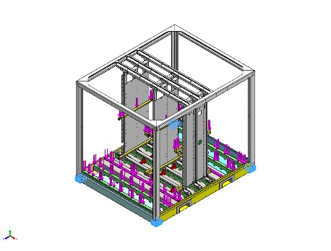 |  | SolidBody 1(Fillet11)(P000008405FLR-2),  SolidBody 1(Fillet11)(P000008405FLR-3),  SolidBody 1(<P000003232>-<Fillet11>)(P000008411FLR-1),  SolidBody 1(<P000003232>-<Fillet11>)(P000008411FLR-2)
  Name: | CARBON STEEL
  Model type: | Linear Elastic Isotropic
  Default failure criterion: | Unknown
  Yield strength: | 2.82685e+08 N/m^2
  Tensile strength: | 4.25e+08 N/m^2
  Elastic modulus: | 2.05e+11 N/m^2
  Poisson's ratio: | 0.29
  Mass density: | 7,858 kg/m^3
  Shear modulus: | 8e+10 N/m^2
  Thermal expansion coefficient: | 1.2e-05 /Kelvin
Curve Data:N/A
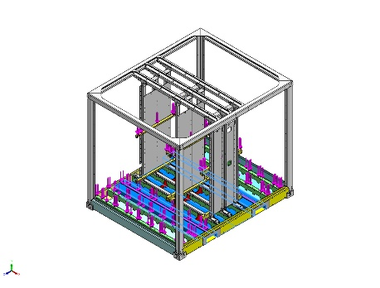 |  | SolidBody 1(Boss-Extrude2)(P000014147FLR-1),  SolidBody 1(Boss-Extrude2)(P000014147FLR-2)
  Name: | 1.0577 (S355J2)
  Model type: | Linear Elastic Isotropic
  Default failure criterion: | Max von Mises Stress
  Yield strength: | 3.15e+08 N/m^2
  Tensile strength: | 4.9e+08 N/m^2
  Elastic modulus: | 2.1e+11 N/m^2
  Poisson's ratio: | 0.28
  Mass density: | 7,800 kg/m^3
  Shear modulus: | 7.9e+10 N/m^2
  Thermal expansion coefficient: | 1.1e-05 /Kelvin
Curve Data:N/A

Loads and Fixtures
Fixture name | Fixture Image | Fixture Details
Reference Geometry-1 | 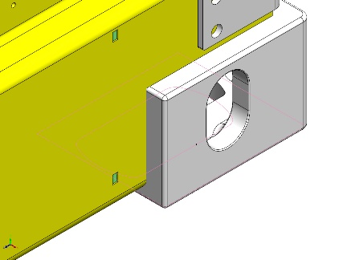
  Entities: | 1 vertex(s)
  Reference: | Face< 1 >
  Type: | Use reference geometry
  Translation: | 0, 0, ---
  Rotation: | 0, 0, 0
  Units: | mm, rad
Resultant Forces
Components | X | Y | Z | Resultant
Reaction force(N) | -0.000172734 | 6.1957e-05 | 0.000415623 | 0.000454333
Reaction Moment(N.m) | 0 | 0 | 0 | 1e-33

Virtual wall-2714 | 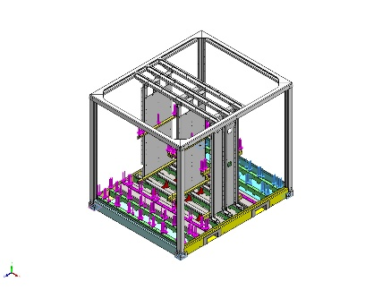
  Type: | Virtual wall
  Entities: | 4 face(s), 1 plane(s)
  Wall Type: | Rigid

Load name | Load Image | Load Details
Force-4 | 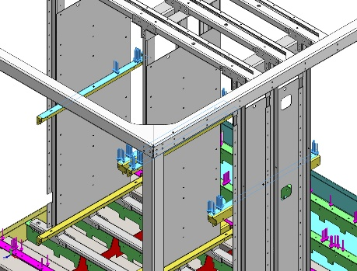
  Entities: | 4 face(s)
  Type: | Apply normal force
  Value: | 113,000 N
Force-5 | 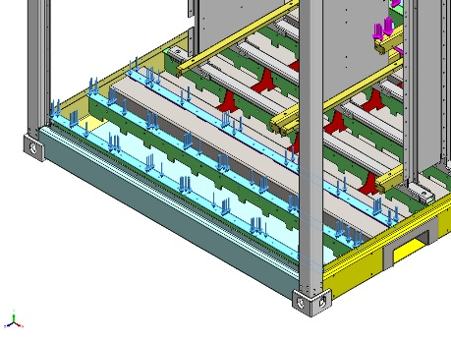
  Entities: | 3 face(s)
  Type: | Apply normal force
  Value: | 39,101 N
Force-6 | 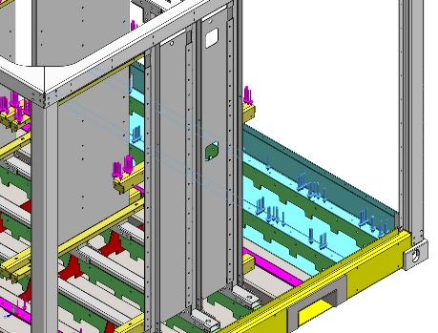
  Entities: | 2 face(s)
  Type: | Apply normal force
  Value: | 900 N

Connector Definitions
No Data

Contact Information

Contact | Contact Image | Contact Properties
Contact Set-19483 | 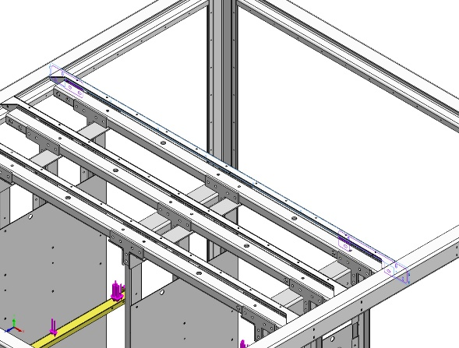
  Type: | Bonded contact pair
  Entities: | 3 face(s)
Contact Set-19484 | 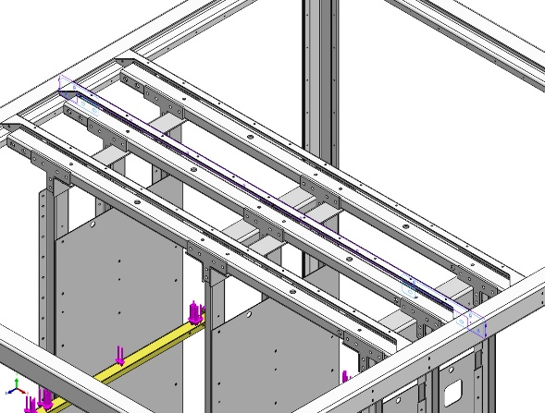
  Type: | Bonded contact pair
  Entities: | 3 face(s)
Contact Set-19485 | 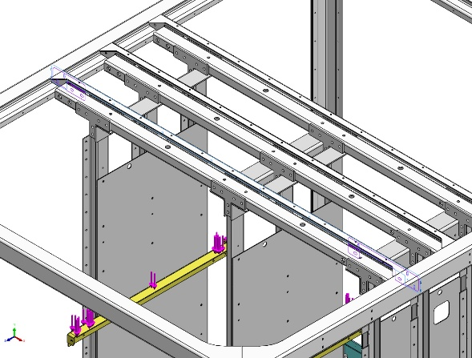
  Type: | Bonded contact pair
  Entities: | 3 face(s)
Global Contact | 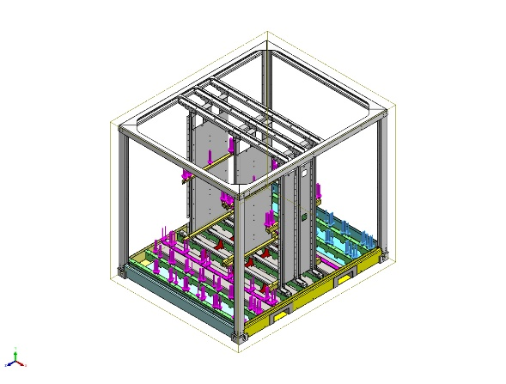
  Type: | Bonded
  Components: | 1 component(s)
  Options: | Compatible mesh

Mesh information
Mesh type | Mixed Mesh
Mesher Used: | Curvature-based mesh
Jacobian points for High quality mesh | 16 Points
Jacobian check for shell | On
Maximum element size | 82.6068 mm
Minimum element size | 27.5353 mm
Mesh Quality | High
Remesh failed parts with incompatible mesh | On

Mesh information - Details
Total Nodes | 467688
Total Elements | 228059
Time to complete mesh(hh;mm;ss): | 00:14:36
Computer name: | VES11D-007DT9S
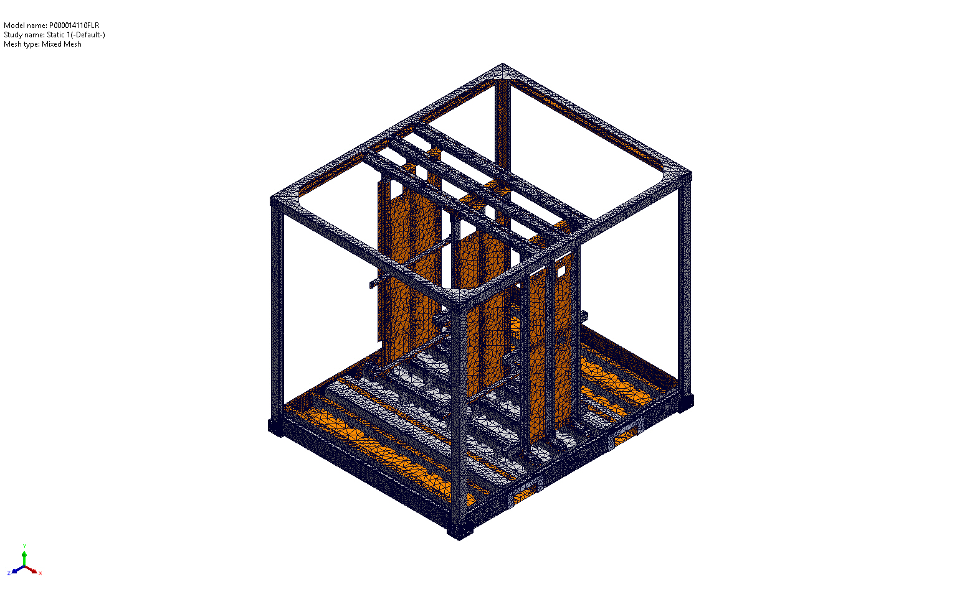

Mesh Control Information:
Mesh Control Name | Mesh Control Image | Mesh Control Details
Control-1 | 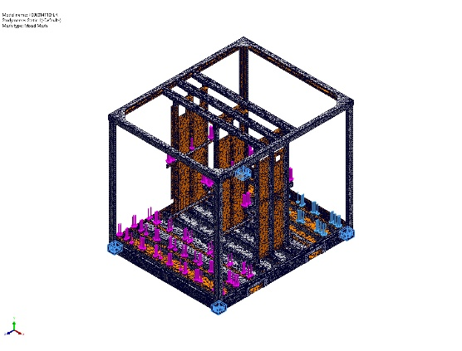
  Entities: | 4 Solid Body (s)
  Units: | mm
  Size: | 15
  Ratio: | 15
Control-4 | 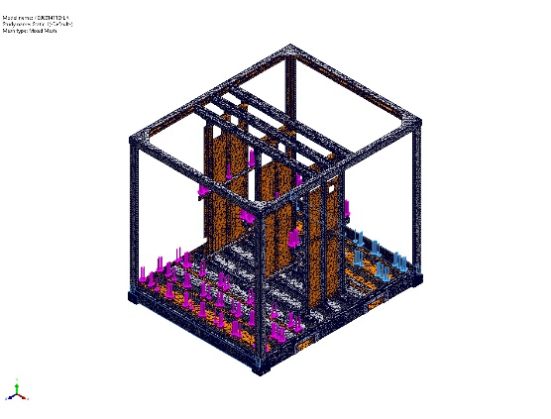
  Entities: | 2 face(s)
  Units: | mm
  Size: | 20
  Ratio: | 20
Control-5 | 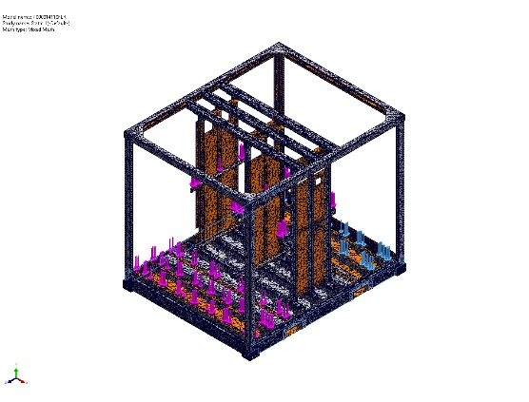
  Entities: | 2 face(s)
  Units: | mm
  Size: | 19.4126
  Ratio: | 19.4126
Control-7 | 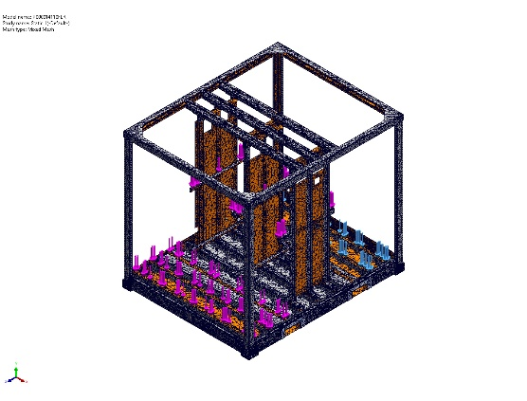
  Entities: | 8 face(s)
  Units: | mm
  Size: | 2
  Ratio: | 2

Sensor Details
No Data

Resultant Forces

Reaction forces
Selection set | Units | Sum X | Sum Y | Sum Z | Resultant
Entire Model | N | -0.000172734 | 6.1957e-05 | 0.000415623 | 0.000454333

Reaction Moments
Selection set | Units | Sum X | Sum Y | Sum Z | Resultant
Entire Model | N.m | 0 | 0 | 0 | 1e-33

Free body forces
Selection set | Units | Sum X | Sum Y | Sum Z | Resultant
Entire Model | N | 0.0191854 | -1.17231 | -0.143149 | 1.18118

Free body moments
Selection set | Units | Sum X | Sum Y | Sum Z | Resultant
Entire Model | N.m | 60.2563 | 2.99003 | 4.19899 | 60.4763

Beams
No Data

Study Results

Name | Type | Min | Max
Stress1 | VON: von Mises Stress | 7.653e+02N/m^2  Node: 52815 | 1.060e+09N/m^2  Node: 142136
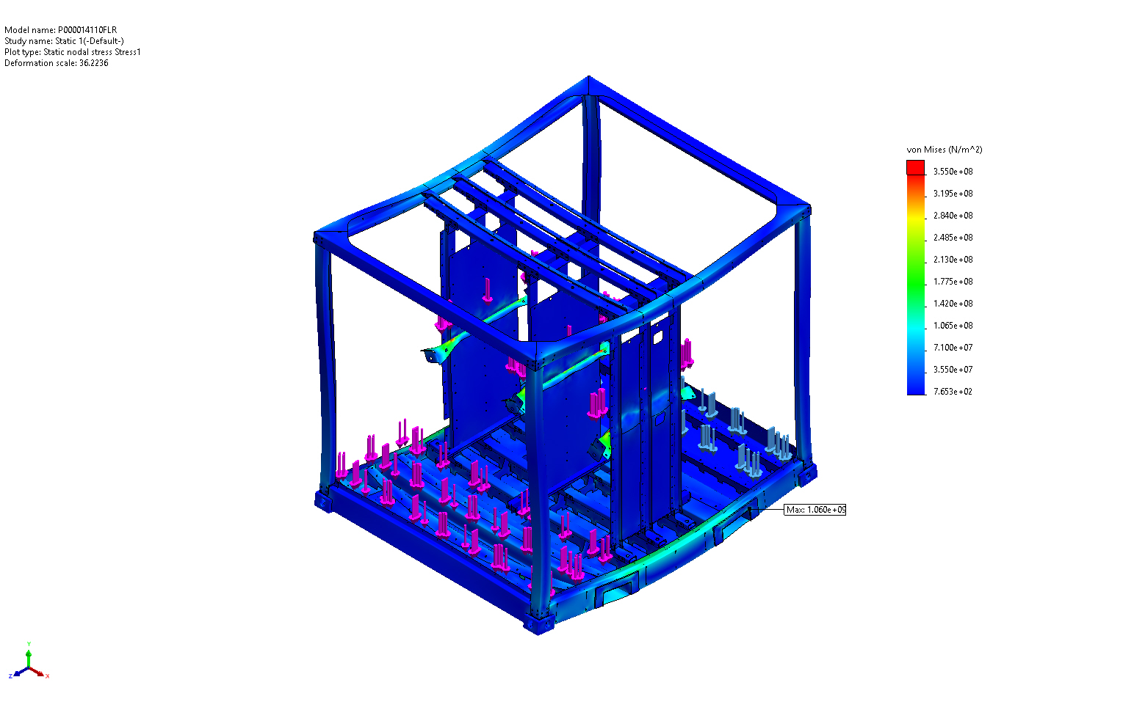
P000014110FLR-Static 1-Stress-Stress1

Name | Type | Min | Max
Displacement1 | URES: Resultant Displacement | 9.788e-06mm  Node: 451168 | 8.300e+00mm  Node: 48162
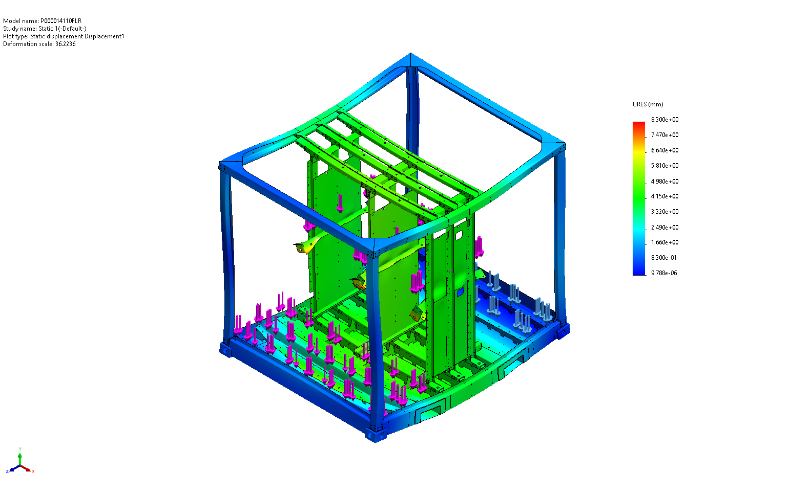
P000014110FLR-Static 1-Displacement-Displacement1

Name | Type | Min | Max
Strain1 | ESTRN: Equivalent Strain | 2.448e-09  Element: 23175 | 1.622e-03  Element: 69330
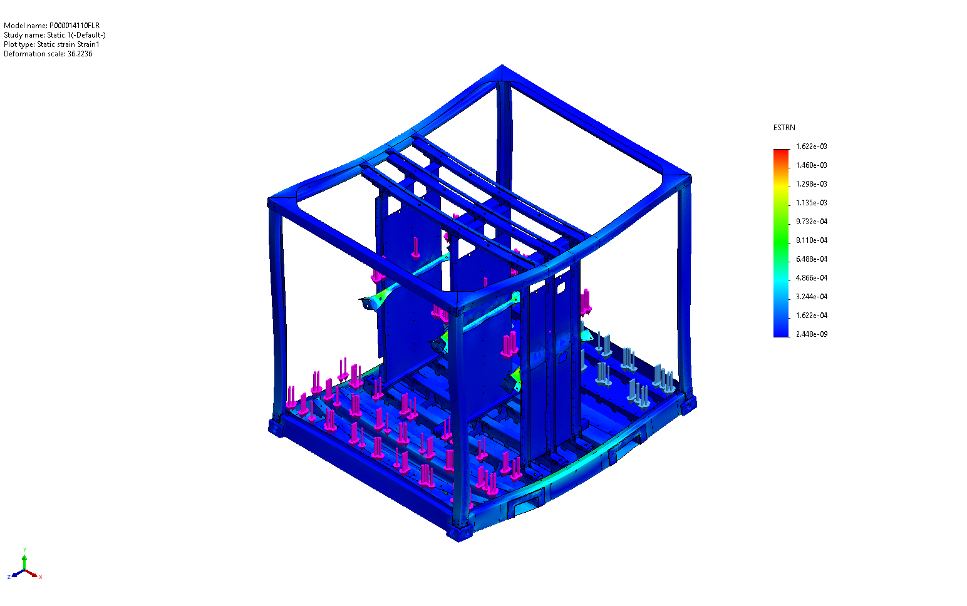
P000014110FLR-Static 1-Strain-Strain1

Name | Type
Displacement1{1} | Deformed shape
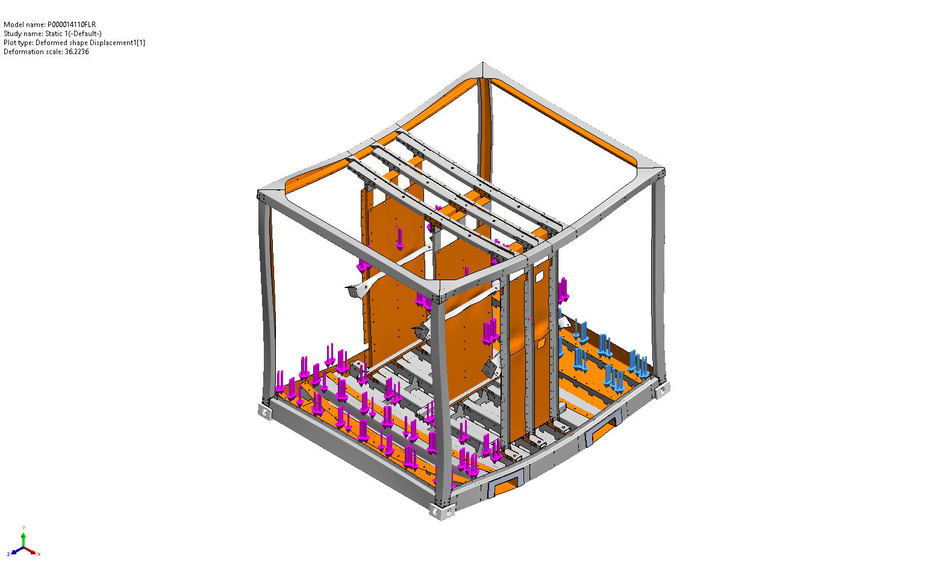
P000014110FLR-Static 1-Displacement-Displacement1{1}

Conclusion

Appendix

